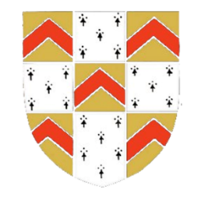
Why not become a Friend of
the City of Lichfield Concert Band?
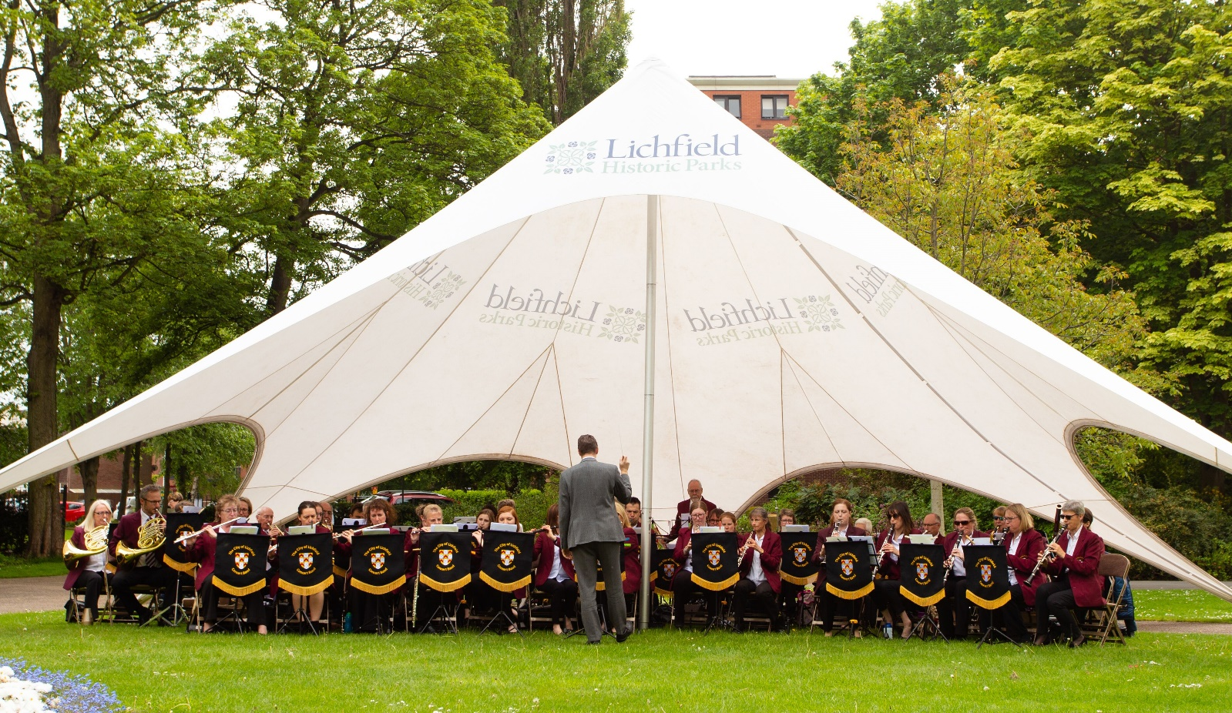

Individual membership costs just £15 per year (or £25 per couple) and entitles you to FREE entry to a concert of your choosing and two FREE newsletters.

www.lichfieldconcertband.co.uk
lichfieldconcertband@gmail.com
Find us on Facebook and Twitter

This Photo by Unknown Author is licensed under CC BY-SA
This Photo by Unknown Author is licensed under CC BY-SA
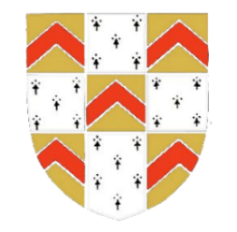
Friends of the City of Lichfield Concert Band Membership Form
Name: ___________________________________________________________________________

Address: ____________________________________________________________________

_____________________________________________________________________ Post Code: _______________

Email: _____________________________

I do not have an email address and would like to receive newsletters/other communications by post.

Telephone: _____________________________

I would like Joint Membership and my partner’s name is: _____________________________

I/we would be happy for my/our name/s to be included in a Friends Membership List on future concert programmes/band publicity.

Please enrol me/us as a member/s of the Friends group.

________________________________________ _________________________________________________
Signature of Main Contact Name of Main Contact (please print)

________________________________________ _________________________________________________
Signature of Second Contact, if applicable Name of Second Contact, if applicable (please print)

Date: _____________________

Annual Membership Costs
We ask for an annual donation of £15 for single membership and £25 for joint membership.

Please tick one of the following boxes and delete text as appropriate:

My/our donation is enclosed as cash/cheque.

Please make your cheque payable to ‘City of Lichfield Concert Band’.

My/our donation has been paid via BACS (bank transfer), with the following reference:
‘FRIENDS [please insert your name here]’

Please use the following information for your BACS payment:

- Sort code: 40 28 18
- Account number: 31150642
- Reference: ‘FRIENDS’ followed by your name

Hand this completed form (together with your cash or cheque if applicable) to a member of the band,
or send your form and cheque by post to: John Wharton (COLCB Treasurer), 22 Footherley Road, Shenstone, Lichfield, Staffordshire, WS14 0NJ,
or send your form and BACS payment reference by email to lichfieldconcertband@gmail.com (FAO Cathy Owens).

You will receive a confirmation email once we have received your form and donation.

Boost your donation by 25p of Gift Aid for every £1 you donate.
Gift Aid is reclaimed by the charity from the tax you pay for the current tax year. Your address is needed to identify you as a current UK taxpayer.
I, (_______________________) want to Gift Aid my donation and any donations I make in the future to: City of Lichfield Concert Band 1170801.
I am a UK taxpayer and understand that if I pay less Income Tax and/or Capital Gains Tax than the amount of Gift Aid claimed on all my donations in that tax year it is my responsibility to pay any difference.
Please notify the charity if you:
- want to cancel this declaration,
- change your name or home address,
- no longer pay sufficient tax on your income and/or capital gains. If you pay Income Tax at the higher or additional rate and want to receive the additional tax relief due to you, you must include all your Gift Aid donations on your Self-Assessment tax return or ask HM Revenue and Customs to adjust your tax code.

Data Protection
The City of Lichfield Concert Band takes the protection of your data seriously. By completing this form you consent to the data you have supplied to be processed and kept securely for the purposes of:
- recording of individual donations and maintenance of running totals,
- reporting of donations for Gift Aid collection and maintenance of accounting records,
- sending you information in accordance with your ‘Friends of Lichfield Concert Band membership’. This includes but is not limited to newsletters, information about your membership and upcoming band events.
The data supplied on this form will not be shared with any third party or used for any other purposes. Our full data protection policy can be provided upon request.

